**Lab 3: Android LinearLayout**

# **Introduction**

Linear Layout is used to align the children in vertical or horizontal manner.

**Attributes of Linear Layout**

|  |  |
| --- | --- |
| **Name of the Attribute** | **Specification** |
| id | Used for unique identification |
| baselineAligned | It has true or false value and used for controlling baseline view. |
| baselineAlignedChildIndex | It specify the child for base. |
| divider | This is used separator between buttons |
| gravity | Used to specify child position |
| orientation | This attribute specify the vertical or horizontal placement. |
| weightSum | Child weight Sum |

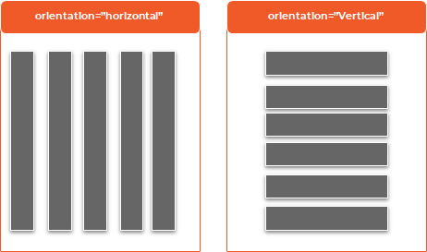

**Let’s get Started:**

**Step 1: Create a New Project in Android Studio as shown below**

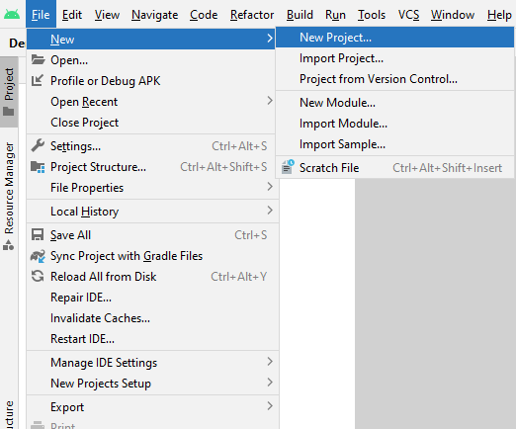

**Step 2: Select Empty Activity as shown below**

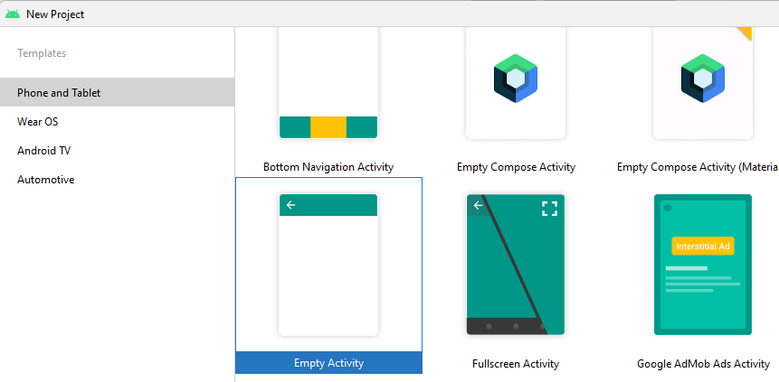

**Step 3: Provide a Project Name as shown below**

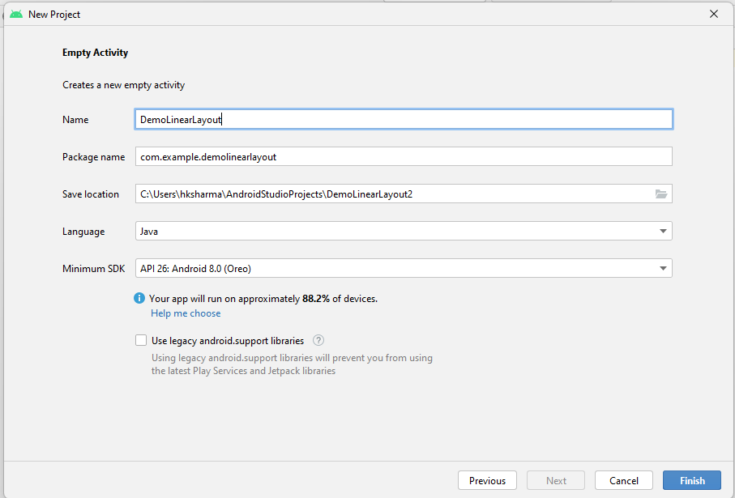

**Step 4: Update MainActivity.java as per the code given below**

**package** com.example.demolinearlayout;  
**import** androidx.appcompat.app.AppCompatActivity;  
**import** android.os.Bundle;  
**public class** MainActivity **extends** AppCompatActivity {  
 @Override  
 **protected void** onCreate(Bundle savedInstanceState) {  
 **super**.onCreate(savedInstanceState);  
 setContentView(R.layout.***activity_main***);  
 }  
}

**Step 5: Update activity_main.xml for Vertical Orientation as per the code given below**

*<?***xml version="1.0" encoding="utf-8"***?>*<**LinearLayout xmlns:android="http://schemas.android.com/apk/res/android"  
 android:layout_width="fill_parent"  
 android:layout_height="fill_parent"  
 android:orientation="vertical"** >  
 <**Button android:id="@+id/btn1"  
 android:layout_width="300dp"  
 android:layout_height="wrap_content"  
 android:text="Click Button 1"**/>  
  
 <**Button android:id="@+id/btn2"  
 android:layout_width="300dp"  
 android:layout_height="wrap_content"  
 android:text="Click Button 2"**/>  
  
 <**Button android:id="@+id/btn3"  
 android:layout_width="300dp"  
 android:layout_height="wrap_content"  
 android:text="Click Button 3"**/>  
 <**Button android:id="@+id/btn4"  
 android:layout_width="300dp"  
 android:layout_height="wrap_content"  
 android:text="Click Button 4"**/>  
</**LinearLayout**>

**Step 6: Check Output on Android Emulator and it should look like as given below**

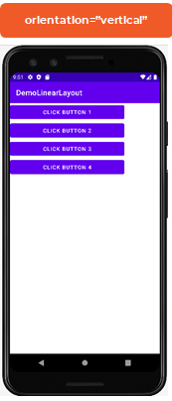

**Step 7: Update activity_main.xml for Horizontal Orientation as per the code given below**

*<?***xml version="1.0" encoding="utf-8"***?>*<**LinearLayout xmlns:android="http://schemas.android.com/apk/res/android"  
 android:layout_width="fill_parent"  
 android:layout_height="fill_parent"  
 android:orientation="horizontal"** >  
 <**Button android:id="@+id/btn1"  
 android:layout_width="100dp"  
 android:layout_height="wrap_content"  
 android:text="Click Button 1"**/>  
  
 <**Button android:id="@+id/btn2"  
 android:layout_width="100dp"  
 android:layout_height="wrap_content"  
 android:text="Click Button 2"**/>  
  
 <**Button android:id="@+id/btn3"  
 android:layout_width="100dp"  
 android:layout_height="wrap_content"  
 android:text="Click Button 3"**/>  
 <**Button android:id="@+id/btn4"  
 android:layout_width="100dp"  
 android:layout_height="wrap_content"  
 android:text="Click Button 4"**/>  
</**LinearLayout**>

**Step 8: Check Output on Android Emulator and it should look like as given below**

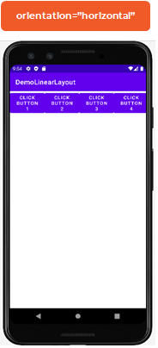

**Voila!!** We have successfully completed this lab.